PKI Asymmetric encryption key/digital certificate generation

Creating Private Root Key

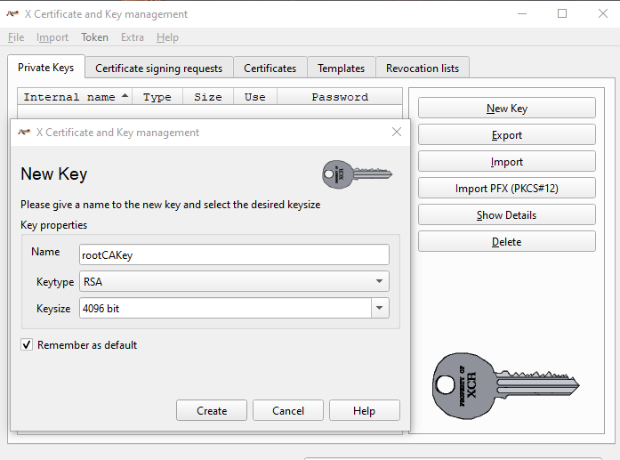

Create a Template

Create a x.509 digital certificate

Have a user create a signing request

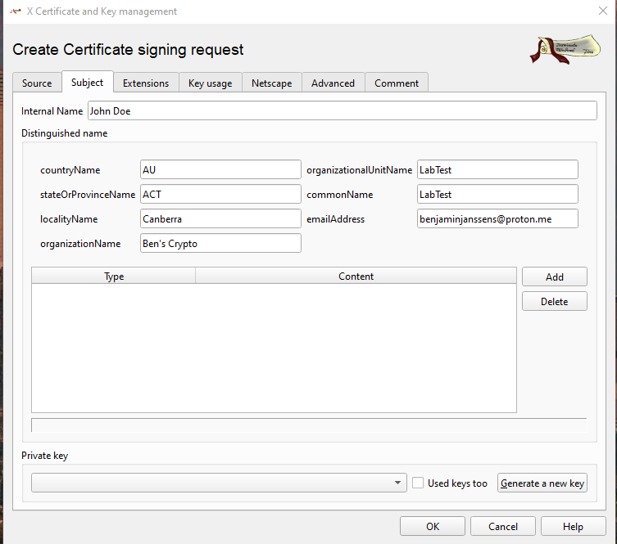

Create users private key

